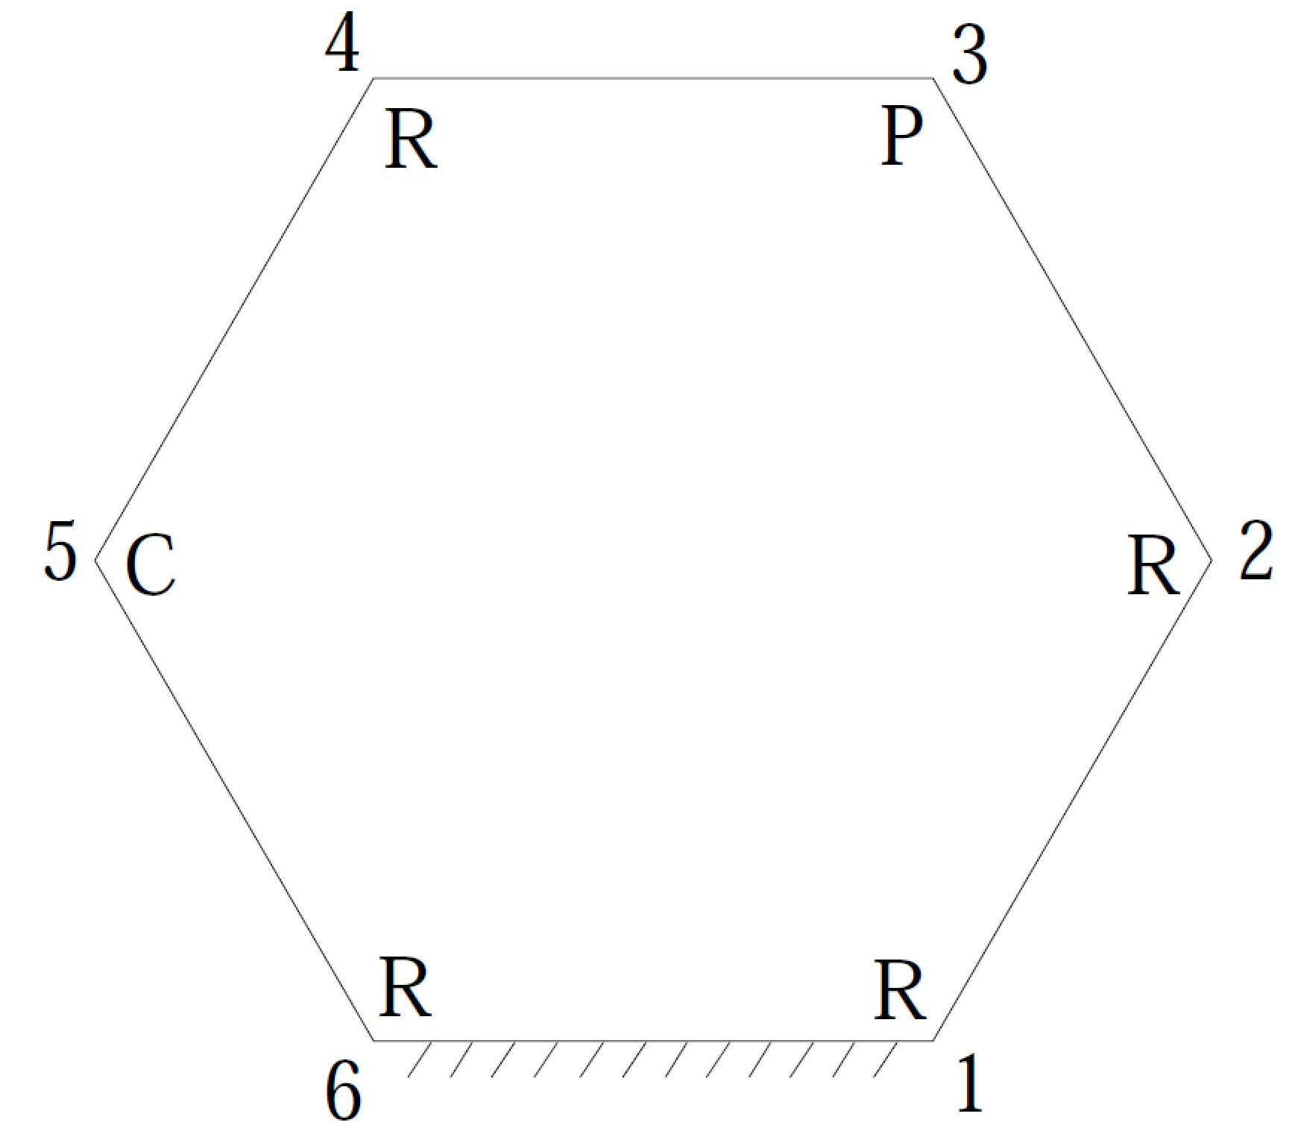

Given:

|  |  |  |  |
| --- | --- | --- | --- |
| link lengths, cm | twist angles, deg. | joint offsets, cm | joint angles, deg. |
| S1 = 6.0 | α12 = 47.5 | a12 = 5.5 |  |
| S2 = 4.5 | α23 = 221.0 | a23 = 3.6 |  |
|  | α34 = 115.0 | a34 = 7.2 | θ3 = 90.0 |
| S4 = 7.5 | α45 = 38.5 | a45 = 2.8 |  |
|  | α56 = 295.0 | a56 = 3.8 |  |
| S6 = 3.9 | α61 = 45.0 | a61 = 6.2 | θ6 = 220.0 (input angle) |

Find:

θ1, θ2, θ4, θ5

S3, S5

Solution:

Insert dual angles into the subsidiary cosine law Z612 = Z4 .



where



Evaluating the partial derivatives gives



Simplifying the S1 term gives



The terms in Z0612 contain the unknown angles θ1 and θ2. The terms in Z04 contain the unknown angle θ4. The following subsidiary sine and sine-cosine laws will be used to substitute for  and :



The only term that remains that contains θ4 is Y4. Expanding its definition and multiplying by gives



Adding and subtracting the term  to the numerator gives



which can be written as



The subsidiary cosine law  is substituted into the previous equation to give



The secondary cosine law  can now be written as

 (1)

This equation contains the angles θ1 and θ2 as its only unknowns. It will be paired with the fundamental cosine law

Z6123 = c45 . (2)

Equation (2) is factored into the format

c2(A1c1+B1s1+D1) + s2(E1c1+F1s1+G1) + (H1c1+I1s1+J1) = 0

where

A1 = s34 * (Y6 * c12 * c23 * c3 + X6 * s3) + c34 * s23 * c12 * Y6;

B1 = s34 * (X6 * c12 * c23 * c3 - Y6 * s3) + c34 * s23 * c12 * X6;

D1 = -s12 * Z6 * (c23 * c3 * s34 + c34 * s23);

E1 = s34 * (c23 * X6 * c3 - c12 * Y6 * s3) + c34 * s23 * X6;

F1 = s34 * (-c12 * X6 * s3 - c23 * Y6 * c3) - c34 * s23 * Y6;

G1 = Z6 * s12 * s3 * s34;

H1 = -Y6 * c3 * s12 * s23 * s34 + Y6 * c23 * c34 * s12;

I1 = -X6 * c3 * s12 * s23 * s34 + X6 * c23 * c34 * s12;

J1 = -Z6 * (c3 * s23 * s34 - c23 * c34) * c12 - c45;

Equation (1) is factored into the format

c2(A2c1+B2s1+D2) + s2(E2c1+F2s1+G2) + (H2c1+I2s1+J2) = 0

where

A2 = S6 * s56 * c12 * c61 * s23 * s6 + S1 * X6 * c12 * s23 + S2 * s23 * X6 + a56 * (-c12 * c56 * c6 * c61 * s23 + c12 * s23 * s56 * s61) + a61 * (c12 * c6 * s23 * s56 * s61 - c12 * c56 * c61 * s23) - a12 * s23 * s12 * Y6 + a23 * c12 * Y6 * c23 - S4 * s34 * (-Y6 * c12 * c23 * s3 + X6 * c3) + a34 * (Y6 * c12 * c23 * c3 + X6 * s3) - a45 * s23 * c12 * Y6 * c45 / s45;

B2 = S6 * s56 * c12 * s23 * c6 - S1 * Y6 * c12 * s23 - S2 * s23 * Y6 + a56 * c56 * c12 * s23 * s6 - a12 * s23 * s12 * X6 + a23 * c12 * X6 * c23 - S4 * s34 * (-X6 * c12 * c23 * s3 - Y6 * c3) + a34 * (X6 * c12 * c23 * c3 - Y6 * s3) - a45 * s23 * c12 * X6 * c45 / s45;

D2 = (((((-S6 * s6 * s61 + c61 * (a61 * c6 + a56)) * s56 + c56 * s61 * (a56 * c6 + a61)) * s23 - c23 * Z6 * (S4 * s3 * s34 + a34 * c3 + a23)) * s12 - c12 * s23 * Z6 * a12) * s45 + Z6 * a45 * c45 * s12 * s23) / s45;

E2 = S6 * s56 * c6 * s23 - S1 * s23 * Y6 - S2 * s23 * c12 * Y6 + a56 * c56 * s23 * s6 + a23 * c23 * X6 - S4 * s34 * (-X6 * c23 * s3 - Y6 * c12 * c3) + a34 * (X6 * c23 * c3 - Y6 * c12 * s3) - a45 * s23 * X6 * c45 / s45;

F2 = -S6 * s56 * c61 * s23 * s6 - S1 * s23 * X6 - S2 * s23 * c12 * X6 + a56 * (c56 * c6 * c61 * s23 - s23 * s56 * s61) + a61 * (-c6 * s23 * s56 * s61 + c56 * c61 * s23) - a23 * c23 * Y6 - S4 * s34 * (-X6 * c12 * c3 + Y6 * c23 * s3) + a34 * (-X6 * c12 * s3 - Y6 * c23 * c3) + a45 * s23 * Y6 * c45 / s45;

G2 = Z6 * s12 * (-S4 * c3 * s34 + S2 * s23 + a34 * s3);

H2 = S6 * s56 * c23 * c61 * s12 * s6 + S1 * X6 * c23 * s12 + a56 * (-c23 * c56 * c6 * c61 * s12 + c23 * s12 * s56 * s61) + a61 * (c23 * c6 * s12 * s56 * s61 - c23 * c56 * c61 * s12) + a12 * c12 * Y6 * c23 - a23 * s23 * s12 * Y6 - S4 * s34 * s23 * s12 * Y6 * s3 - a34 * s23 * s12 * Y6 * c3 - a45 * c23 * s12 * Y6 * c45 / s45;

I2 = S6 * s56 * c23 * s12 * c6 - S1 * Y6 * c23 * s12 + a56 * c56 * c23 * s12 * s6 + a12 * c12 * X6 * c23 - a23 * s23 * s12 * X6 - S4 * s34 * s23 * s12 * X6 * s3 - a34 * s23 * s12 * X6 * c3 - a45 * c23 * s12 * X6 * c45 / s45;

J2 = (((((S6 * s6 * s61 - c61 * (a61 * c6 + a56)) * s56 - c56 * s61 * (a56 * c6 + a61)) * c23 - s23 * Z6 * (S4 * s3 * s34 + a34 * c3 + a23)) * c12 - c23 * s12 * Z6 * a12) * s45 - a45 * (Z6 * c12 * c23 * c45 - c34)) / s45;

Obtain corresponding value for S3 by projecting vector loop onto **a**45 .



Obtain corresponding value for S5 by projecting vector loop onto **S**5.



SolidWorks solution:

th1 = 150.83610 deg

th2 = -120.8818

th4 = -98.8100

th5 = -127.2712

S3 = 11.71326 cm

S5 = - 7.3492 cm